ASEN 5090-001 Homework #06

Submitted By

Charles Goble

Aerospace Engineering Sciences Department

University of Colorado at Boulder

Submitted: November 2, 2016

**Table of Contents**

Executive Summary 03

Objective 04

Method and Procedure 05

Results/Discussion 06

Conclusions and Recommendations 11

References 12

Appendix A: MATLAB CODE 13

**Executive Summary**

This document outlines the problem solving process and results for the set homework assignment. The document is broken down into several sections. The first section is the objective section. One objective has been identified. Following the objective section is the methods and procedures. The work completed is straightforward. The results section follows the method/procedure section. The results obtained are consistent with the expected results. The analysis and discussion section describes in detail how each of the results are obtained. Following the analysis and discussion section is the conclusion and recommendation section. This section is short, again, this assignment is straightforward and does not necessarily require a large report to show results. The final sections are the references and the appendix. All MATLAB code generated to complete the assignment has been submitted to the reader in the appendix.

**Objective**

The objective of this document is to fully demonstrate adequate understanding of the covered course material as well as present solutions to assigned problem using proper engineering problem solving processes. Specifically, the main learning outcome of this homework assignment is to gain a thorough understanding of concepts of characteristics and accuracy of GPS point positioning.

**Methods and Procedures**

The methodology and procedures followed are straight forward and concise. All procedures used to solve the problem are from either course notes or the course textbook. The most direct approach was used to solve all of the problems. All computations, used MATLAB as the programming language to compute the solution.

**Results and Discussion**

Problem 1: Compute and submit the mean X, Y, Z position and subtract this from each of the recorded values to find the deviations dX, dY, and dZ. Compute the latitude, longitude and height of the mean position.

The equation used to determine the mean is the standard equation:

$$mean=\frac{1}{n}\sum_{i=1}^{n}{x_{i}}$$

Table 1: Mean ECEF positions from data file

|  |  |  |
| --- | --- | --- |
| X [m] | 2102929.36970537 | 2102929.37 ± 0.63 |
| Y [m] | 721619.88603448 | 721619.87 ± 0.84 |
| Z [m] | 5958197.63956717 | 5958197.6 ± 2.1 |

Using the function developed earlier in the course the Latitude, Longitude and height are:

Table 2: Mean Latitude, Longitude and Height

|  |  |
| --- | --- |
| Latitude [degrees] | 69.66271 |
| Longitude [degrees] | 18.93965 |
| Height [meters] | 139.72 |

Problem 2: Convert the deviations in WGS-84 to ENU deviations

The procedure to rotate the position vector from the ECEF frame to the ENU frame is straightforward. A direction cosine matrix is used to compute the conversion.

$$\overset{⃑}{r_{ENU}}=\left[Q\right]\overset{⃑}{r_{ECEF}}$$

$$Q=ROT1\left(90-ϕ\right)ROT3(90+λ)$$

$$Q=\left[\begin{matrix}1 & 0 & 0 \\ 0 & cos\left(90-ϕ\right) & sin\left(90-ϕ\right) \\ 0 & -sin\left(90-ϕ\right) & cos\left(90-ϕ\right)\end{matrix}\right]\left[\begin{matrix}cos\left(90+λ\right) & sin\left(90+λ\right) & 0 \\ -sin\left(90+λ\right) & cos\left(90+λ\right) & 0 \\ 0 & 0 & 1\end{matrix}\right]$$

Table 3: Mean position in ENU frame

|  |  |
| --- | --- |
| East [m] | -10.1089873397101E-12 |
| North [m] | -13.9554876135955 E03 |
| Up [m] | 6.35947887412162 E06 |

Table 4: Partial tabulation of deviations in ENU frame

|  |  |  |  |
| --- | --- | --- | --- |
| Time [s] | East [m] | North [m] | Up [m] |
| 86400 | -750.78485 E-03 | 524.91059 E-03 | 1.04684651 |
| 86430 | -583.33353 E-03 | 461.55981 E-03 | -986.38867 E-03 |
| 86460 | 298.36885 E-03 | 362.13339 E-03 | 1.01706072 |

Problem 3: Plot the East, North, and height deviations versus time on separate graphs. Describe any interesting or unusual features in your results. See if you can determine what causes them.

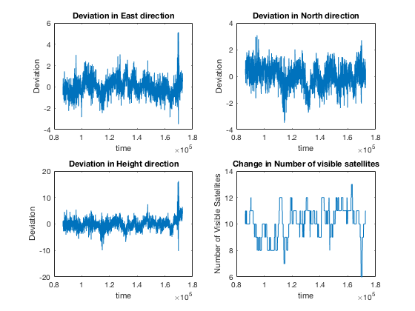  
Figure 1: Deviations versus time and satellite coverage versus time

Looking at the results from figure 1 it is clear that there is a correlation between the amount of error in the position and the number of satellites visible to the receiver. This is illustrated at a time of 1.7 x 105 seconds where the number of visible satellites drops down to only 6. At this corresponding time the error in each of the plots jumps up to their highest values.

Problem 4: Make a scatter plot of the North versus East error in meters. When you make the plot be sure that the grid is square.

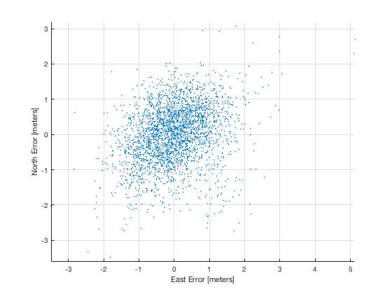  
Figure 2: Scatter plot of North versus East error in meters

Problem 5: Compute and submit the standard deviations of the North, East and height errors in meters.

The equation for standard deviation is:

$$σ=\sqrt{\frac{\sum_{1}^{n}{x_{i}-{\overline{x}}_{i}}}{n-1}}$$

where xi is the ith point and $\overline{x}$ is the mean and n represents the total number of data points. Using the above equation, the following standard deviations were calculated.

Table 5: Standard deviations of ENU deviations

|  |  |
| --- | --- |
| East [meters] | 0.82 |
| North [meters] | 0.82 |
| Height [meters] | 2.04 |

Problem 6: For the East-North errors, find a) the error covariance matrix; b) the semi-major and semi-minor axis of the error ellipse; and c) the 50 % CEP.

The error covariance matrix is defined as:

$$P=\left[\begin{matrix}σ_{x} & \frac{\sum_{1}^{n}{δx_{i}δy_{i}}}{n-1} \\ \frac{\sum_{1}^{n}{δx_{i}δy_{i}}}{n-1} & σ_{y}\end{matrix}\right]$$

$$P=\left[\begin{matrix}0.6727 & 0.1956 \\ 0.1956 & 0.6671\end{matrix}\right]$$

The semi-major axis the larger of the two standard deviations squared and the semi-minor axis is the smaller of the two standard deviations squared.

Table 6: Semi-Major and Semi-Minor Axes

|  |  |
| --- | --- |
| Semi-major Axis [meters] | 0.93 |
| Semi-minor Axis [meters] | 0.69 |

Two different 50% CEPs are found. The first is an approximation that has an error of plus/minus three percent. The second 50% CEP is the exact value.

Approximation: 50% CEP = $0.59\left(σ_{x}+σ_{y}\right)$ = 0.97

Exact Value: 50% CEP = $median\left(\sqrt{{δ_{x}}^{2}+{δ_{y}}^{2}}\right)$ = 0.89

Problem 7: Plot the 1σ horizontal error ellipse and 50% CEP on your scatter plot

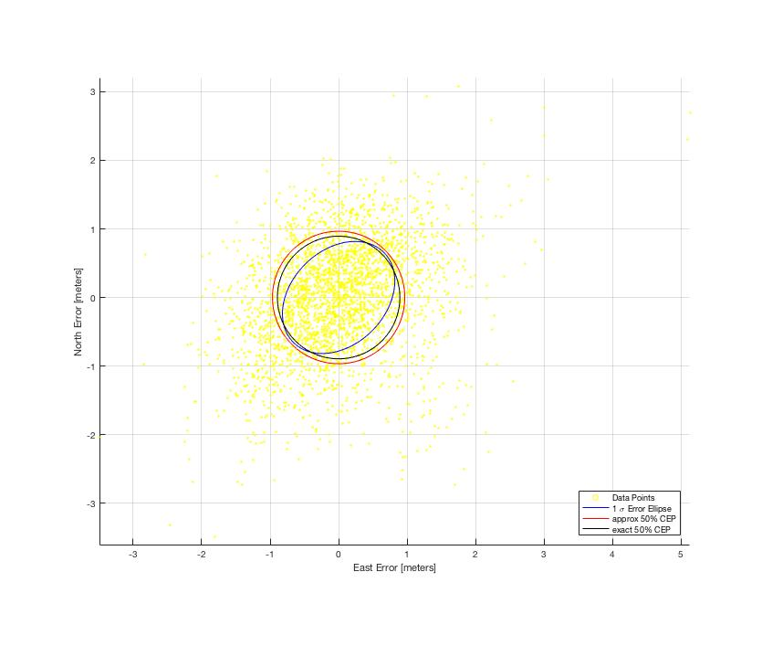  
Figure 3: 1σ Error Ellipse and 50% CEP

**Conclusions and Recommendations**

Concluding, this homework set has been successful and has meet the objective of the assignment. Overall, the assignment was straight forward and not very challenging, it allowed the author to think critically about the real GPS data and how error can affect position determination.

References

1. Misra, Pratap, and Per Enge. *Global Positioning System: Signals, Measurements, and Performance*. Lincoln, MA: Ganga-Jamuna, 2011. Print.

Appendix A: MATLAB CODE

% ASEN 5090 HW # 6

% Author: CG

close all; clear all; clc; format longeng;

S = load('GPS_positions2.mat');

data = S.data;

% Problem 1: Compute and submit the mean X, Y, Z, position, and subtract

% this from each of the recorded values to find the deviations dX, dY, dZ.

% Compute the latitude, longitude, and height of the mean position.

xCol = data(:,2); yCol = data(:,3); zCol = data(:,4);

% find the average of each column

xAvg = sum(xCol)/length(xCol);

fprintf('The average for X in ECEF is %f km\n',xAvg)

yAvg = sum(yCol)/length(yCol);

fprintf('The average for Y in ECEF is %f km\n',yAvg)

zAvg = sum(zCol)/length(zCol);

fprintf('The average for Z in ECEF is %f km\n',zAvg)

me = mean(data);

% find the deviations from each column of data

dX = xCol - xAvg;

dY = yCol - yAvg;

dZ = zCol - zAvg;

% Compute the latitude, longitude, and height of the mean position.

lla = ecef2lla([xAvg, yAvg, zAvg]);

latitude = lla(1);

fprintf('The Latitude is %f degrees\n', latitude)

longitude = lla(2);

fprintf('The Longitude is %f degrees\n', longitude)

height = lla(3);

fprintf('The height is %f meters\n', height)

% Problem 2: Convert the deviation in WGS-84 to ENU deviations.

devMatECEF = [dX, dY, dZ];

Q = ROT1(90-latitude)*ROT3(90+longitude);

disp('The rotation matrix for ECEF to ENU is:')

disp(Q)

for ii = 1:1:length(devMatECEF)

devMatENU(ii,:) = Q*devMatECEF(ii,:)';

end

me = mean(devMatENU);

fprintf('The average E deviation is %E meters\n',me(1))

fprintf('The average N deviation is %E meters\n',me(2))

fprintf('The average U deviation is %E meters\n',me(3))

% Problem 3: Plot the East, North, and Height deviations versus time on

% separate graphs.

figure()

subplot(2,2,1)

plot(data(:,1),devMatENU(:,1))

title('Deviation in East direction')

ylabel('Deviation')

xlabel('time')

hold on

subplot(2,2,2)

plot(data(:,1),devMatENU(:,2))

title('Deviation in North direction')

ylabel('Deviation')

xlabel('time')

subplot(2,2,3)

plot(data(:,1),devMatENU(:,3))

title('Deviation in Height direction')

ylabel('Deviation')

xlabel('time')

subplot(2,2,4)

plot(data(:,1),data(:,5))

title('Change in Number of visible satellites')

ylabel('Number of Visible Satellites')

xlabel('time')

% Problem 4: Make a scatter plot of the North error vs East error in

% meters. When you make the plot be sure that the grid is square.

figure()

s = linspace(1,10,length(devMatENU));

c = linspace(1,10,length(devMatENU));

scatter(devMatENU(:,1),devMatENU(:,2),1)

xlabel('East Error [meters]')

ylabel('North Error [meters]')

axis square

grid on

% Compute and submit the standard deviations of the N, E, and height errors

% in meters.

E_std = std(devMatENU(:,1));

fprintf('The standard deviation for E is %f\n',E_std)

N_std = std(devMatENU(:,2));

fprintf('The standard deviation for N is %f\n',N_std)

H_std = std(devMatENU(:,3));

fprintf('The standard deviation for U is %f\n',H_std)

% For the East-North errors, find a) the error covariance matrix; b) the

% semimajor and semiminor axes of the error ellipse; and c) the 50 % CEP

varN = N_std^2;

varE = E_std^2;

corner = sum(devMatENU(:,1)'*devMatENU(:,2))/(length(devMatENU) - 1);

P = [varN,corner;corner,varE];

disp('The covariance matrix is:')

disp(P)

[eigVec, eigVal] = eig(P);

semiMajorAxis = sqrt(max(max(eigVal)));

fprintf('The semi-major axis is %f\n',semiMajorAxis)

semiMinorAxis = sqrt(min(max(eigVal)));

fprintf('The semi-major axis is %f\n',semiMinorAxis)

CEP = 0.59*(N_std + E_std);

fprintf('The CEP approximation is %f\n',CEP)

cep50 = median((sqrt(devMatENU(:,1).^2 + devMatENU(:,2).^2)));

fprintf('The CEP for 50 percent is %f\n',cep50)

th = atan2(eigVec(2,1),eigVec(1,1));

fprintf('The angle offset of the ellipse is %f radians\n', -th)

figure()

s = linspace(1,10,length(devMatENU));

c = linspace(1,10,length(devMatENU));

scatter(devMatENU(:,1),devMatENU(:,2),3,'y')

hold on

axis equal

grid on

xlabel('East Error [meters]')

ylabel('North Error [meters]')

C = drawellipse(semiMajorAxis, semiMinorAxis, -th, me(1), me(2),'b');

D = drawellipse(CEP,CEP,-th,me(1),me(2),'r');

E = drawellipse(cep50,cep50,-th,me(1),me(2),'k');

legend('Data Points','1 \sigma Error Ellipse','approx 50% CEP','exact 50% CEP','Location','SouthEast')